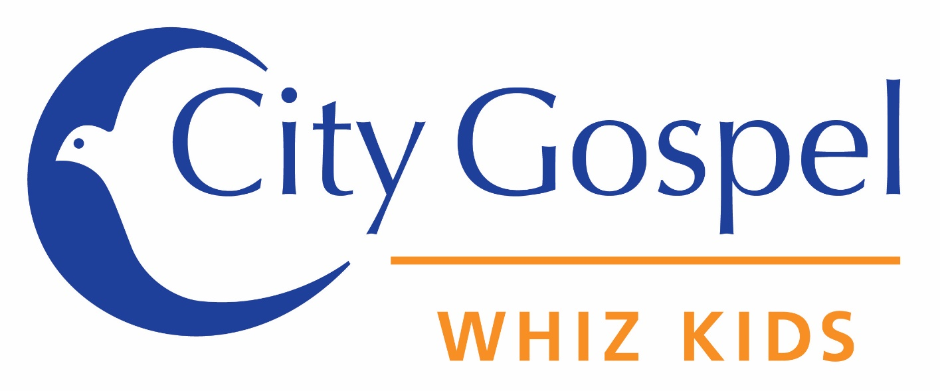

Give one hour a week, change two lives…
Take action in your community!

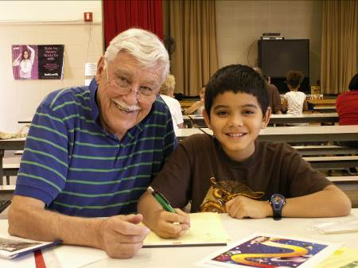
WHAT WE WANT
We want you!! Tutors meet after school with the same child each week during the school year to work on reading skills and to build positive, caring relationships. You don’t have to be an educator to make a difference in their lives. If you can read, you can do this. Training and supplies are provided each week; you just have to show up!

There is a Whiz Kid
who NEEDS YOU!

WHY WHIZ KIDS?
Research shows that students who can't read by 4th grade are 4 times more likely to drop out. Once you learn to read, you read to learn. It is not a lack of intelligence that holds these students back, but rather a lack of support systems and role models. You can change a child’s life by simply sharing your valuable skill of reading with them, and by becoming that support system and role model they need to succeed.

WHO WE ARE
Established in 2005,Whiz Kids is a youth ministry of City Gospel Mission that pairs local churches with local elementary schools to provide one hour of literacy-based, highly relational tutoring after school each week to at-risk youth. We minister to financially under-resourced children who are behind in their reading levels and would benefit from a stable relationship with a caring adult.

